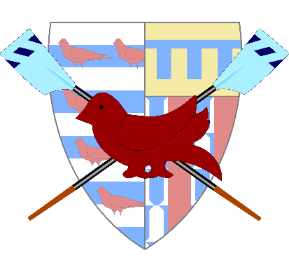

[**Pembroke**](http://regatta.pembrokecollegeboatclub.com/)**| Regatta 2025**

**Saturday 15th February**

**General Information and Marshalling Instructions**

(to be read in conjunction with the Rules of the Regatta)

1. **General Information**
   1. The Regatta will be held on Saturday 15th February, 2025
   2. The Draw and Racing Timetable will be posted on the Pembroke College Boat Club website on Wednesday 12th February, 2025. Crews should familiarise themselves with all potential marshalling and race times.
   3. Any crews intending to scratch should inform the Regatta Secretary as soon as possible
   4. Crew numbers will be available for collection from Pembroke Boathouse from 7:00am on the day of the Regatta
   5. Results, including times, will be posted on the Pembroke College Boat Club website during the day of the Regatta
   6. There will be a presentation of prizes to winning crews at Pembroke Boathouse at 12:00pm on Sunday 16th February. Crews unable to make this should contact the Regatta Secretary to arrange collection
2. **Updates and Contact Details**
3. Any changes to the running of the Regatta made before the day of the Regatta (e.g. due to a poor weather forecast) will be communicated to crews via email and also posted on the Pembroke College Boat Club website.
4. Any updates made on the day of the Regatta (e.g. due to weather conditions) will be communicated to crews via email and SMS, and also posted on the website
5. An updated refund policy is intact this year:
   1. If the regatta is fully cancelled on the day/day before, a 60% refund will be issued to all crews to cover the cost of the regatta.
   2. If only the Lower boat division is cancelled on the day/day before, a 100% refund will be issued to the crews affected.
   3. If you scratch before entries close, a 100% refund will be issued.
   4. If you scratch after entries close but before the draw is out, a 50% refund will be issued, otherwise there will be no refund.
6. The Senior Umpire may be contacted on the day of the Regatta on: 07914 242705
7. **Marshalling**
   1. Crew numbers must be clearly displayed by the cox and bow-person at ALL times when marshalling and racing. Three copies of the crew number will be provided to each crew.
   2. Crews should row as normal to Chesterton Footbridge (Green Dragon Footbridge). Crews must be below Chesterton Footbridge no later than the time stated in the Racing Timetable.
   3. On arrival at Chesterton, crews should seek instruction from the Marshals there. If the course is clear, crews will be instructed to continue to the Railway Bridge. If the course is not clear, crews should pull in on the Meadowside at Chesterton under Marshals’ instructions.
   4. When instructed, crews should continue downstream to the Railway Bridge, obeying normal navigation rules. On arrival at the Railway Bridge, crews should pull in on the Towpath side, under Marshals’ instructions, unless told otherwise.
   5. A set of races will then be run from the end of the Long Reach to Peter’s Posts. Crews marshalled at the Railway Bridge should be aware of the racing crews as they pass, and if necessary should bury their blades to avoid those of the racing crews.
   6. Once the last of the races has passed the Railway Bridge, crews should push off and row to Grassy Corner/First Post corner, obeying normal navigation rules. A single practice start is permitted underneath the Railway Bridge, unless marshals state otherwise.
   7. On arriving at Grassy/First Post corner, crews should spin and pull in on the towpath side, under Marshals’ instructions. Crews will be in reverse racing order as they row downstream, so the last pair of crews may be asked to spin and row straight up to the start.

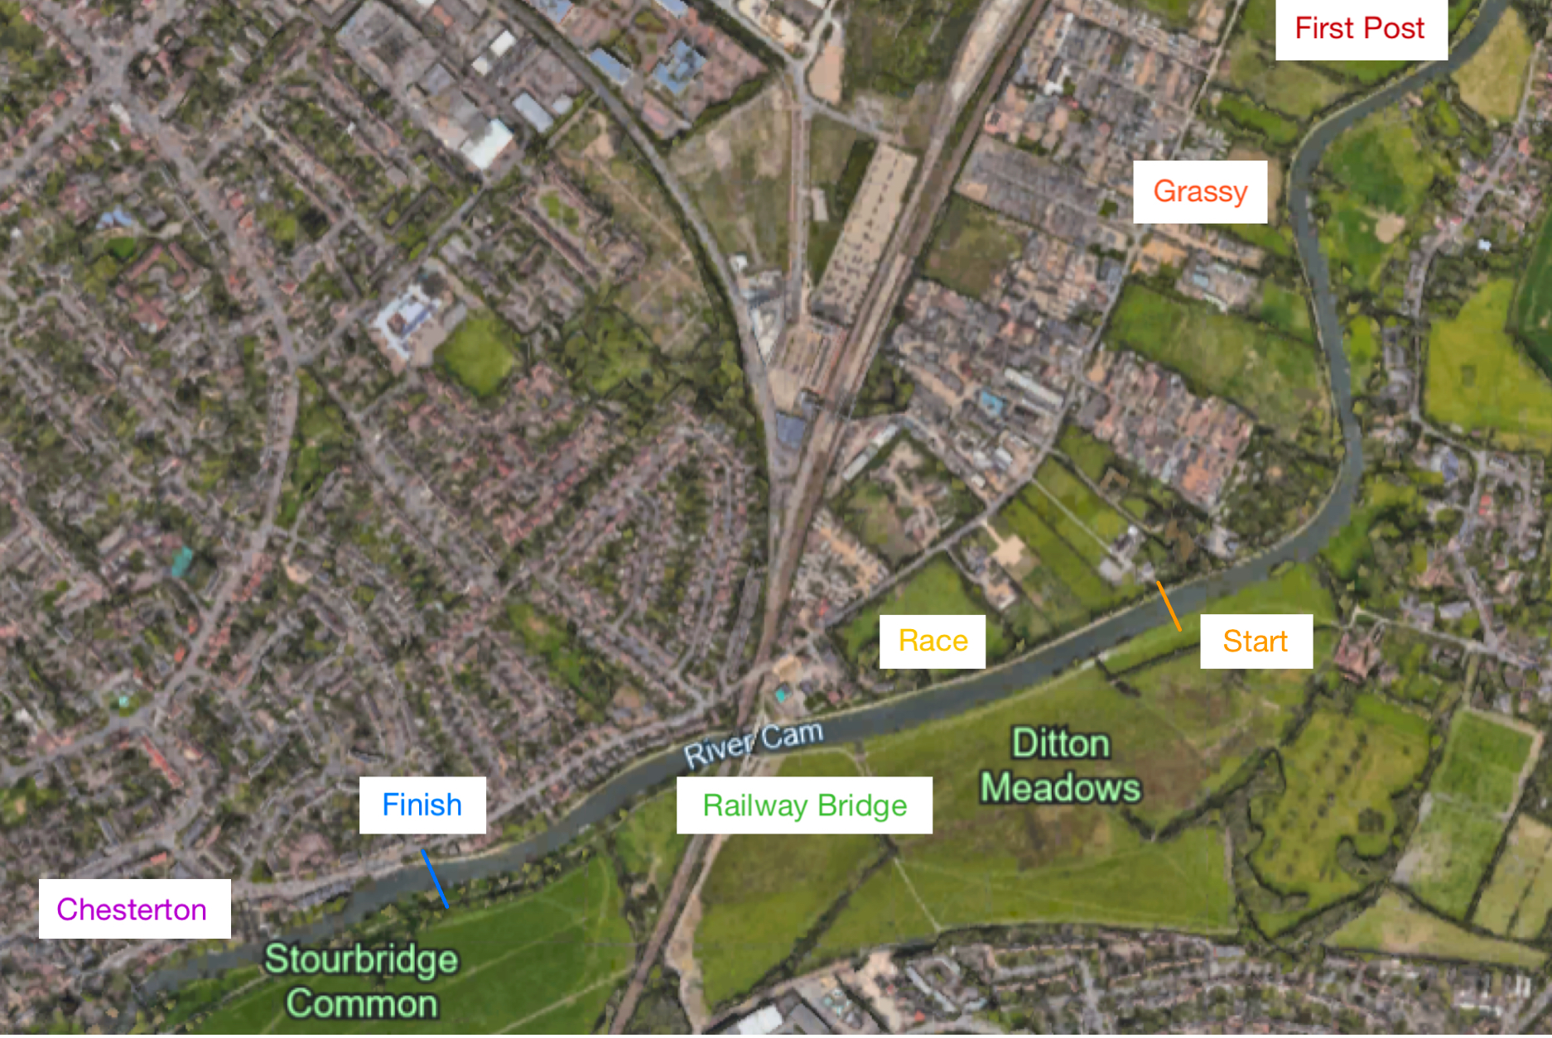

1. **Racing**
   1. When instructed, crews should row up to the start line, so as to have their bow in line with the first Stump at the end of the Long Reach. On arriving at the start, coxes should raise their hand (the hand closest to the Umpire) and bring their crew forward to race. As soon as the cox is satisfied that they are straight and their crew is ready they should lower their hand. Crew members must be alert to any commands given by their cox or by the Start Umpire, who will ensure crews are straight and level before starting the race.
   2. The Start Umpire will start the race under the command “Attention, GO!” If the Start Umpire deems both crews to be straight and ready to race, they may elect to start the race regardless of whether a cox’s hand is raised.
   3. Crews must maintain station throughout the race, regardless of the position of the other crew. Crews which cross the centre-line of the river will be warned back on station by their Race Umpire with a single whistle. Failure to act on such warnings may result in disqualification.
   4. The emergency stop signal will be a SUSTAINED BLAST on a siren. Upon hearing this signal all crews must stop.
   5. At the finish, a short blast on an airhorn will be given to signify that the crew has completed the race. Crews must continue rowing at light pressure until well clear of the finish line as other racing crews will be following.
2. **After Racing**
3. Losing crews should continue to row until above Chesterton Footbridge. They should then return to their boathouse obeying normal navigation rules.
4. Winning crews should be aware whether they are to remain on the river for their next race, or whether they have an extended break. Marshals will advise. Crews with an extended break should return to their boathouse, obeying normal navigation rules.
5. Crews required to remain on the river for their next race should pull in on the Meadowside at Chesterton, under Marshals’ instructions. As soon as the river is clear, crews should spin and row to the Railway Bridge to marshal for their next race.
6. **Bank Parties**
7. Bank parties are restricted to 4 persons on bicycles. Bank parties may not overtake the Race Umpire, who will normally cycle with the leading crew
8. **Safety**
   1. Attention is drawn to the following Safety Regulations:
      1. All coxes must wear a serviceable life jacket when on the river, and must be able to demonstrate how to inflate it
      2. All boats must be correctly fitted with a bow-ball
      3. All boats must be fitted with heel restraints which comply with BR regulations. Concept II type footplates must be modified in accordance with BR guidelines.
      4. All boats must have covers correctly fitted to all hatches, and canvasses must be watertight

Crews which do not comply with these regulations will not be permitted to race.

* 1. First Aid will be provided as required by a crew stationed by Peter’s Posts as well as at the start.
  2. All crews should dress appropriately for the weather conditions on the day. We will turn away crews not dressed appropriately for the weather.
  3. Information will be posted on the Pembroke College Boat Club website and emailed to captains in the days leading up to the Regatta. Bank parties are kindly requested to help ensure their crews are properly equipped.

*Rosie Clifton, Regatta Secretary & Senior Umpire 2025*